White Paper

Title: XC Modem Battery Charging From USB Port

Author: Curtis Bradford

Introduction

This paper describes the battery charger designed into the XC modem and describes the voltage and cable requirements of the USB port that will properly power the modem and charge the internal battery.

The figure 1 is a simplified diagram of XC Modem battery charger input. This battery charger chip only has a single input voltage so the 12V and USB input voltages are combined using diodes. There are dual input battery chargers available but their maximum input voltage range is only 10V. The input voltage range of the Bq24196 used in the modem is 17V. This input range is required to handle the real world 12V seen in a vehicle.

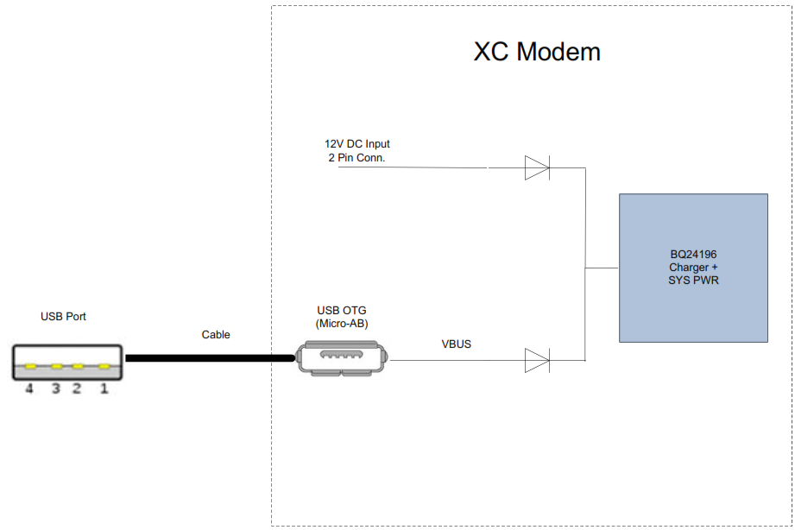

The input charger current on the 12V input is set for 2A maximum, and the charger current on the USB input is set to 500mA maximum. 500mA was chosen because it is enough current to run the modem and charge the battery, and it is not too much current for most USB ports to supply. The modem consumes between 200mA and 250mA when running, so that leaves 250mA - 300mA to charge the battery. If the modem is turned off, then all 500mA is used to charge the battery. At 500mA, it will take approximately 7 hours to charge the battery. Note: It takes less than 2 hours to charge using 12V input.

Figure 2 shows the voltages in the USB input path to the charger chip. As mentioned above, the price paid for using a single input charger chip is the addition of diodes in the input voltage path. These diodes have a 0.3V drop at 500mA or higher charging currents. The minimum voltage seen at the charger chip must be 4.45V in order to fully charge the battery to 4.35V. This means that the input voltage at the modem’s USB connector must be at least 4.75V. This further means that the voltage at the USB source port must be 4.75V + the voltage drop of the cable. The figure shows an example if the cable has approx. 0.1V of drop.

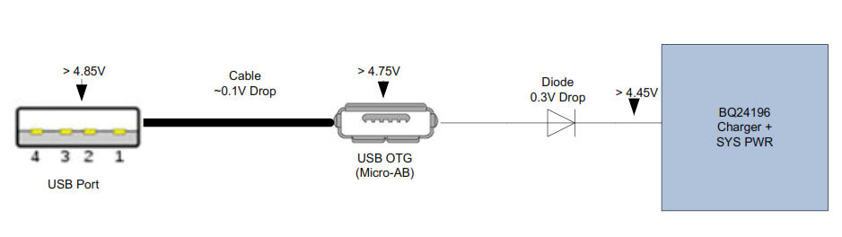

Different USB cables have been measured and their drop ranged from 0.1V to 0.8V while supplying 500mA of current. For example, if a cable with 0.1V of drop is used, then the source USB port must have a voltage of 4.85V to ensure full charging of the battery. Obviously, a cable with more than 0.25V has no chance of working since it would require a voltage of over 5V at the source USB port. It was found that USB cables of good quality of up to 3 ft. in length will only have 0.1V of drop. Flextronics recommends using cables of 3 ft. or less length with at least 28 AWG wire size for charging the modem. Cables with 24 AWG for the VDD and GND are available as well and will lower the drop a little more. Obviously, a USB voltage source that is as close to 5V when supplying 500mA is also required.